

**SP21 JavaScript dumps 1 Set 1**

1. `Refer to the code below:



1. const exec = (item, delay) =>{
2. new Promise(resolve => setTimeout( () => resolve(item), delay)), 03 async function runParallel() {

04 Const (result1, result2, result3) = awaitPromise.all{ 05

[exec (‘x’, ‘100’) , exec(‘y’, 500), exec(‘z’,‘100’)]

06 );

07 return `parallel is done: $(result1)$(result2)$(result3)`; 08

}

}

}

Which two statements correctly execute the runParallel () function? Choose 2 answers

1. Async runParallel () .then(data);
2. runParallel ( ). done(function(data){ return data;

});

1. runParallel () .then(data);
2. runParallel () .then(function(data) return data;

});

Answer: B, D

1. A developer needs to test this function: 01

const sum3 = (arr) => (

1. if (!arr.length) return 0,
2. if (arr.length === 1) return arr[0],
3. if (arr.length === 2) return arr[0] + arr[1],
4. return arr[0] + arr[1] + arr[2], 06 );

Which two assert statements are valid tests for the function? Choose 2 answers

[www.salesforcekeeda.com](http://www.salesforcekeeda.com/) Telegram: @Salesforcekeeda

# console.assert(sum3(1, ‘2’)) == 12);

* 1. console.assert(sum3(0)) == 0);



[www.salesforcekeeda.com](http://www.salesforcekeeda.com/) Telegram: @Salesforcekeeda

# console.assert(sum3(-3, 2 )) == -1);

* 1. console.assert(sum3(‘hello’, 2, 3, 4)) === NaN);

**Answer**: AC

1. Which statement phrases successfully?
   1. JSON.parse ( ‘ foo ’ );
   2. JSON.parse ( “ foo ” );
   3. JSON.parse( “ ‘ foo ’ ” );



# JSON.parse(‘ “ foo ” ’);

**Answer:** D

1. Refer to the code below:
2. let car1 = new promise((_, reject) =>
3. setTimeout(reject, 2000, “Car 1 crashed in”));
4. let car2 = new Promise(resolve => setTimeout(resolve, 1500, “Car 2

completed”));

1. let car3 = new Promise(resolve => setTimeout (resolve, 3000, “Car 3

Completed”));

1. Promise.race([car1, car2, car3]) 06

.then(value => (

07 let result = $(value) the race. `; 08

))

09 .catch( arr => (

10 console.log(“Race is cancelled.”, err); 11

));

What is the value of result when Promise.race executes?

1. Car 3 completed the race.
2. Car 1 crashed in the race. C. Car 2 completed the race.

D. Race is cancelled.

Answer: C

[www.salesforcekeeda.com](http://www.salesforcekeeda.com/) Telegram: @Salesforcekeeda

1. Refer to the code below:

for(let number =2 ; number <= 5 ; number += 1 ) {



// insert code statement here

}

The developer needs to insert a code statement in the location shown. The code statement has these requirements:

1. Does require an import
2. Logs an error when the boolean statement evaluates to false
3. Works in both the browser and Node.js Which meet the requirements?
   1. assert (number % 2 === 0);
   2. console.error(number % 2 === 0);
   3. console.debug(number % 2 === 0);
   4. console.assert(number % 2 === 0); Answer:B
4. A developer is working on an ecommerce website where the delivery date is dynamically calculated based on the current day. The code line below is responsible for this calculation.

Const deliveryDate = new Date ();

Due to changes in the business requirements, the delivery date must now be today’s date + 9

days.

Which code meets this new requirement?

# deliveryDate.setDate(( new Date ( )).getDate () +9);

* 1. deliveryDate.setDate( Date.current () + 9);
  2. deliveryDate.date = new Date(+9) ;
  3. deliveryDate.date = Date.current () + 9;

[www.salesforcekeeda.com](http://www.salesforcekeeda.com/) Telegram: @Salesforcekeeda

**Answer**: A

1. Which three statements are true about promises ? Choose 3 answers



**A. The executor of a new Promise runs automatically. B. A**

**Promise has a .then() method.**

1. **A fulfilled or rejected promise will not change states.**
2. A settled promise can become resolved.
3. A pending promise can become fulfilled, settled, or rejected.

**Answer:** BCE

8.

Given the code below:

What should a developer insert at line 15 to output the following message using the method ?

|  |  |  |
| --- | --- | --- |
| 01 | function GameConsole (name) { 02 this.name = name; |  |
| 03 | } |
| 04 |  |
| 05 | GameConsole.prototype.load = function(gamename) { |
| 06 | console.log( ` $(this.name) is loading a game : $(gamename) …`); 07 |
| 08 | )  function Console 16 Bit (name) { |
| 09 | GameConsole.call(this, name) ; 10 } |
| 11 | Console16bit.prototype = Object.create ( GameConsole.prototype) ; |
| 12 | //insert code here |
| 13 | console.log( ` $(this.name) is loading a cartridge game : $(gamename) …`); 14 | } |
| 15 | const console16bit = new Console16bit(‘ SNEGeneziz ’); |  |
| 16 | console16bit.load(‘ Super Nonic 3x Force ’); |  |

> SNEGeneziz is loading a cartridge game: Super Monic 3x Force . . .

* 1. Console16bit.prototype.load(gamename) = function() {

[www.salesforcekeeda.com](http://www.salesforcekeeda.com/) Telegram: @Salesforcekeeda

* 1. Console16bit.prototype.load = function(gamename) {
  2. Console16bit = Object.create(GameConsole.prototype).load = function (gamename) {
  3. Console16bit.prototype.load(gamename) {

wise)

Answer:B (tried in js but question is throwing error but b option is the correct syntax

1. A developer has the following array of student testgrades: Let arr = [ 7, 8, 5, 8, 9 ];



The Teacher wants to double each score and then see an array of the students who scored more than 15 points.

How should the developer implement the request?

* 1. Let arr1 = arr.filter(( val) => ( return val > 15 )) .map (( num) => ( return num *2 ))
  2. Let arr1 = arr.mapBy (( num) => ( return num *2 )) .filterBy (( val ) => return val > 15 ))

;

# C. Let arr1 = arr.map((num) => num*2). Filter (( val) => val > 15);

D. Let arr1 = arr.map((num) => ( num *2)).filterBy((val) => ( val >15 ));

# Answer: C

1. A test has a dependency on database.query. During the test the dependency is replaced with an object called database with the method, query, that returns an array. The developer needs to verify how many times the method was called and the arguments used each time.

Which two test approaches describe the requirement? Choose 2 answers

* 1. Integration
  2. Black box C. White box D. Mocking

Answer:

1. Given the JavaScript below:
2. function filterDOM (searchString) {
3. const parsedSearchString = searchString && searchString.toLowerCase() ; 03

document.quesrySelectorAll(‘ .account’ ) . forEach(account => (

[www.salesforcekeeda.com](http://www.salesforcekeeda.com/) Telegram: @Salesforcekeeda

1. const accountName = account.innerHTML.toLOwerCase();
2. account. Style.display = accountName.includes(parsedSearchString) ? /*Insert code*/; 06 )};

07 }

Which code should replace the placeholder comment on line 05 to hide accounts that do not match the search string?

* 1. ‘ name ’ : ‘ block ’

# B. ‘ Block ’ : ‘ none ’



1. ‘ visible ’ : ‘ hidden ’
2. ‘ hidden ’ : ‘ visible ’

**Answer:** B

12. A developer publishes a new version of a package with new features that do not break backward compatibility. The previous version number was 1.1.3.

Following semantic versioning format, what should the new package version number be?

A. 2.0.0

B. 1.2.3

C. 1.1.4

**D. 1.2.0**

**Answer:** D

13.

A developer is creating a simple webpage with a button. When a user clicks this button for the

first time, a message is displayed.

The developer wrote the JavaScript code below, but something is missing. THe message gets displayed every time a user clicks the button, instead of just the first time.

01

02

03

function listen(event) {

alert ( ‘Hey! I am John Doe’) ;

button.addEventListener (‘click’, listen);

Which two code lines make this code work as required? Choose 2

answers

1. On line 02, use event.first to test if it is the first execution.
2. On line 04, use event.stopPropagation ( ),

[www.salesforcekeeda.com](http://www.salesforcekeeda.com/) Telegram: @Salesforcekeeda

# On line 04, use button.removeEventListener(‘ click” , listen);

1. **On line 06, add an option called once to button.addEventListener().**

**Answer: C,D**



1. A developer uses a parsed JSON string to work with user information as in the block below: 01

const userInformation ={

02 “ id ” : “user-01”,

03 “email” :[“us](mailto:user01@universalcontainers.demo)e[r01@universalcontainers.demo”](mailto:user01@universalcontainers.demo), 04

“age” : 25

Which two options access the email attribute in the object? Choose 2 answers

* 1. **userInformation(“email”)**
  2. userInformation.get(“email”)
  3. **userInformation.email**
  4. userInformation(email)

**Answer:** A,C

15. Refer to the code below:

01

02

const server = require(‘server’);

/* Insert code here */

A developer imports a library that creates a web server. The imported library uses events and callbacks to

start the servers

Which code should be inserted at the line 03 to set up an event and start the web server ?

A. Server.start ();

1. server.on(‘ connect ’ , ( port) => {

console.log(‘Listening on ’ , port) ;})

1. server()

# D. serve(( port) => (

E. console.log( ‘Listening on ’, port) ;

[www.salesforcekeeda.com](http://www.salesforcekeeda.com/) Telegram: @Salesforcekeeda

# Answer: D

1. A developer wants to iterate through an array of objects and count the objects and count the objects whose property value, name, starts with the letter N.

Const arrObj = [{“name” : “Zach”} , {“name” : “Kate”},{“name” : “Alise”},{“name” : “Bob”},{“name” :

“Natham”},{“name” : “nathaniel”}

Refer to the code snippet below:

1. arrObj.reduce(( acc, curr) => { 02



//missing line 02

1. //missing line 03

04 ). 0);

Which missing lines 02 and 03 return the correct count?

* 1. Const sum = curr.startsWith(‘N’) ? 1: 0; Return acc +sum

# B. Const sum = curr.name.startsWith(‘N’) ? 1: 0; Return acc +sum

1. Const sum = curr.startsWIth(‘N’) ? 1: 0; Return curr+ sum
2. Const sum = curr.name.startsWIth(‘N’) ? 1: 0; Return curr+ sum

# Answer: B

1. A developer creates a class that represents a blog post based on the requirement that a Post should have a body author and view count.

The Code shown Below:

Class Post {

// Insert code here This.body =body This.author = author; this.viewCount = viewCount;

}

}

Which statement should be inserted in the placeholder on line 02 to allow for a variable to be set to a new instanceof a Post with the three attributes correctly populated?

* 1. super (body, author, viewCount) {

[www.salesforcekeeda.com](http://www.salesforcekeeda.com/) Telegram: @Salesforcekeeda

* 1. Function Post (body, author, viewCount) {

# C. constructor (body, author, viewCount) {

D. constructor() {

# Answer: C

1. Which three options show valid methods for creating a fat arrow function? Choose 3 answers

# x => ( console.log(‘ executed ’) ; )

* 1. [ ] => ( console.log(‘ executed ’) ;)



# ( ) => ( console.log(‘ executed ’) ;)

* 1. X,y,z => ( console.log(‘ executed ’) ;)

# (x,y,z) => ( console.log(‘ executed ’) ;) Answer: A,C,E

1. Refer to the code below:

const event = new CustomEvent(

//Missing Code

);

obj.dispatchEvent(event);

A developer needs to dispatch a custom event called update to send information about recordId. Which two options could a developer insert at the placeholder in line 02 to achieve this? Choose 2 answers

# ‘Update’ , (

**(**

**recordId : ‘123abc’**

* 1. ‘Update’ , ‘123abc’
  2. { type : ‘update’, recordId : ‘123abc’ }

# ‘Update’ , {

**Details : {**

**recordId : ‘123abc’**

**}**

**}**

**Answer: A,D**

1. Refer to the code below:

[www.salesforcekeeda.com](http://www.salesforcekeeda.com/) Telegram: @Salesforcekeeda

Const pi = 3.1415326, What is the data type of pi?

* 1. Double

# B. Number

1. Decimal
2. Float



**Answer:** B

21.

A developer is required to write a function that calculates the sum of elements in an array

but is getting undefined every time the code is executed. The developer needs to find what is missing

in the code below.

Const sumFunction = arr => {

Return arr.reduce((result, current) => {

//

Result += current;

//

), 10);

);

Which option makes the code work as expected?

1. Replace line 02 with return arr.map(( result, current) => (
2. Replace line 04 with result = result +current;
3. Replace line 03 with if(arr.length == 0 ) ( return 0; )
4. **Replace line 05 with return result; Answer**: D

22. Given code below:

setTimeout (() => (

console.log(1);

). 0);

console.log(2);

New Promise ((resolve, reject )) = > ( setTimeout(() => (

reject(console.log(3));

[www.salesforcekeeda.com](http://www.salesforcekeeda.com/) Telegram: @Salesforcekeeda

). 1000);

)).catch(() => ( console.log(4);

));

console.log(5);

What is logged to the console?

A. 2 1 4 35

# B. 2 5 1 3 4

C. 1 2 4 3 5



D. 1 2 5 3 4

**Answer**: B

1. Which statement accurately describes the behaviour of the async/ await keyworks ?
   1. The associated class contains some asynchronous functions.

# B. The associated function will always return a promise

1. The associated function can only be called via asynchronous methods
2. The associated sometimes returns a promise.

**Answer**: B

1. A developer is debugging a web server that uses Node.js The server hits a runtimeerror every third request to an important endpoint on the web server.

The developer added a break point to the start script, that is at index.js at he root of the server’s

source code. The developer wants to make use of chrome DevTools to debug.

Which command can be run to access DevTools and make sure the breakdown is hit ?

* 1. node -i index.js
  2. Node --inspect-brk index.js
  3. Node inspect index.js

# Node --inspect index.js Answer: D

1. Refer to the code below:

Async funct on functionUnderTest(isOK) { If

(isOK) return ‘OK’ ;

Throw new Error(‘not OK’);

[www.salesforcekeeda.com](http://www.salesforcekeeda.com/) Telegram: @Salesforcekeeda

)

Which assertion accuretely tests the above code?

* 1. Console.assert (await functionUnderTest(true), ‘ OK ’)
  2. Console.assert (await functionUnderTest(true), ‘ not OK ’)
  3. Console.assert (await functionUnderTest(true), ‘ not OK ’)

# D. Console.assert (await functionUnderTest(true), ‘OK’)

**Answer:** D



1. Consider type coercion, what does the following expression evaluate to? True +

3 + ‘100’ + null

A. 104

B. 4100

* 1. ‘3100null’
  2. **‘4100null’**

**Answer:** D

27.

A Developer wrote the following code to test a sum3 function that takes in an array of

numbers and returns the sum of the first three number in the array, The testpasses:

Let res = sum2([1, 2, 3 ]) ; console.assert(res === 6 ); Res = sum3([ 1, 2, 3, 4]);

console.assert(res=== 6);

A different developer made changes to the behavior of sum3 to instead sum all of the numbers present in the array. The test passes:

Which two results occur when running the test on the updated sum3 function ? Choose 2

answers

1. The line 02 assertion passes.
2. The line 02 assertion fails
3. The line 05 assertion passes.
4. The line 05 assertion fails.

[www.salesforcekeeda.com](http://www.salesforcekeeda.com/) Telegram: @Salesforcekeeda

**Answer:** A,D

1. A developer creates a simple webpage with an input field. When a user enters text in the input field and clicks the button, the actual value of the field must be displayed in the console.

Here is the HTML file content:

<input type =” text” value=”Hello” name =”input”>



<button type =”button” >Display </button>

The developer wrote the javascript code below:

Const button = document.querySelector(‘button’); button.addEvenListener(‘click’, () => (

Const input = document.querySelector(‘input’); console.log(input.getAttribute(‘value’));

When the user clicks the button, the output is always “Hello”. What

needs to be done make this code work as expected?

# Replace line 04 with console.log(input .value);

* 1. Replace line 03 with const input = document.getElementByName(‘input’);
  2. Replace line 02 with button.addEventListener(“onclick”, function() {
  3. Replace line 02 with button.addCallback(“click”, function() {

**Answer**: A

1. A developer creates an object where its properties should be immutable and prevent properties from being added or modified.

Which method should be used to execute this business requirement ?

* 1. Object.const()
  2. Object.eval()

# C. Object.lock()

D. Object.freeze()

**Answer**: D

[www.salesforcekeeda.com](http://www.salesforcekeeda.com/) Telegram: @Salesforcekeeda

1. A developer has an ErrorHandler module that contains multiple functions. What kind of export be leverages so that multiple functions can be used?

# Named

* 1. All
  2. Multi
  3. Default

**Answer**: A



1. A team that works on a big project uses npm to deal with projects dependencies.

A developer added a dependency does not get downloaded when they execute npm

install.

Which two reasons could be possible explanations for this? Choose 2 answers

* 1. The developer missed the option --add when adding the dependency.

# The developer added the dependency as a dev dependency, and NODE_ENV

**Is set to production.**

1. **The developer missed the option --save when adding the dependency.**
2. **The developer added the dependency as a dev dependency, and NODE_ENV is set to production.**

**Answer**: B,C,D

1. A developer is asked to fix some bugs reported by users. To do that, the developer adds a breakpoint for debugging.

Function Car (maxSpeed, color){ This.maxspeed =masSpeed; This.color = color;

Let carSpeed = document.getElementById(‘ CarSpeed’); Debugger; Let fourWheels =new Car (carSpeed.value, ‘red’);

When the code execution stops at the breakpoint on line 06, which two types of information are available in the browser console ?

Choose 2 answers:

[www.salesforcekeeda.com](http://www.salesforcekeeda.com/) Telegram: @Salesforcekeeda

* 1. The values of the carSpeed and fourWheels variables
  2. A variable displaying the number of instances created for the Car Object.

# C. The style, event listeners and other attributes applied to the carSpeed DOM element

D. **The information stored in the window.localStorageproperty Answer**: C,D

1. At Universal Containers, every team has its own way of copying JavaScript objects. The code Snippet shows an implementation from one team:



Function Person() {

this.firstName = “John”; this.lastName = ‘Doe’; This.name =() => (

console.log(‘Hello $(this.firstName) $(this.firstName)’);

)}

Const john = new Person ();

Const dan = JSON.parse(JSON.stringify(john));

dan.firstName =’Dan’;

dan.name();

What is the Output of the code execution?

* 1. Hello Dan Doe
  2. Hello John DOe

# C. TypeError: dan.name is not a function

D. TypeError: Assignment to constant variable.

**Answer**: C

1. Refer to the code below:

Let textValue = ’1984’;

Which code assignment shows a correct way to convert this string to an integer?

# let numberValue = Number(textValue);

* 1. Let numberValue = (Number)textValue;
  2. Let numberValue = textValue.toInteger();
  3. Let numberValue = Integer(textValue);

**Answer**: A

[www.salesforcekeeda.com](http://www.salesforcekeeda.com/) Telegram: @Salesforcekeeda

1. A developer writers the code below to calculate the factorial of a given number.

Function factorial(number) {

Return number + factorial(number -1);

}

factorial(3);

What is the result of executing line 04?



1. 0
2. 6
3. -Infinity
4. **RuntimeError Answer**: D
5. Given the following code:

Let x =null; console.log(typeof x);

What is the output of the line 02?

* 1. “Null”
  2. “X”

**C. “Object”**

D. “undefined”

**Answer**: C

1. Which function should a developer use to repeatedly execute code at a fixed interval ?
   1. **setIntervel**
   2. setTimeout
   3. setPeriod
   4. setInteria

**Answer**: A

1. Refer to the code below: Function changeValue(obj) {

Obj.value = obj.value/2;

}

[www.salesforcekeeda.com](http://www.salesforcekeeda.com/) Telegram: @Salesforcekeeda

Const objA = (value: 10); Const objB = objA; changeValue(objB); Const result = objA.value;

What is the value of result after the code executes?

* 1. 10
  2. Nan



1. **5**
2. Undefined

**Answer**: C

1. Given HTML below:

<div>

<div id =”row-uc”> Universal Container</div>

<div id =”row-aa”>Applied Shipping</div>

<div id =”row-bt”> Burlington Textiles </div>

</div>

Which statement adds the priority = account CSS class to the universal COntainers row ?

* 1. Document .querySelector(‘#row-uc’).classes.push(‘priority-account’);

**B. Document .queryElementById(‘row-uc’).addclass(‘priority-account’);**

1. Document .querySelector(‘#row-uc’).classList.add(‘priority-account’);
2. Document .querySelectorALL(‘#row-uc’).classList.add(‘priority-account’);

**Answer**: B

40. Refer to the code below: const addBy = ?

const addByEight =addBy(8); const sum = addBYEight(50);

Which two functions can replace line 01 and return 58 to sum? Choose 2 answers

# const addBy = function(num1){ return function(num2){

**return num1 + num2;**

**}**

1. const addBy = function(num1){

[www.salesforcekeeda.com](http://www.salesforcekeeda.com/) Telegram: @Salesforcekeeda

return num1 + num2;

}

1. const addBy = (num1) => num1 + num2 ;

# const addBY = (num1) => (num2) => num1 + num2; Answer: A,D

1. GIven a value, which three options can a developer use to detect if the value is NaN? Choose 3 answers !



# value == NaN

* 1. **Object.is(value, NaN)**
  2. value === Number.NaN
  3. value ! == value
  4. **Number.isNaN(value) Answer**: A,B,E

1. A developer wants to use a module named universalContainersLib and them call functions from it. How should a developer import every function from the module and then call the fuctions foo and bar ?

# import * ad lib from‘/path/universalContainersLib.js’; lib.foo();

**lib.bar();**

* 1. import (foo, bar) from ‘/path/universalContainersLib.js’;

foo();

bar();

* 1. import all from‘/path/universalContaineraLib.js’; universalContainersLib.foo(); universalContainersLib.bar();
  2. import * from‘/path/universalContaineraLib.js’; universalContainersLib.foo(); universalContainersLib.bar();

**Answer**: A

1. Refer to the code snippet:

Function getAvailabilityMessage(item) { If (getAvailability(item)){

Var msg =”Username available”;

[www.salesforcekeeda.com](http://www.salesforcekeeda.com/) Telegram: @Salesforcekeeda

}

Return msg;

}

A developer writes this code to return a message to user attempting to register a new username. If the username is available, variable.

What is the return value of msg hen getAvailabilityMessage (“newUserName” ) is executed and getAvailability(“newUserName”) returns false?

* 1. “Username available”
  2. “newUserName”



* 1. “Msg is not defined”

# D. undefined

**Answer**: D

1. Given the requirement to refactor the code above to JavaScript class format, which class definition is correct?

[www.salesforcekeeda.com](http://www.salesforcekeeda.com/) Telegram: @Salesforcekeeda

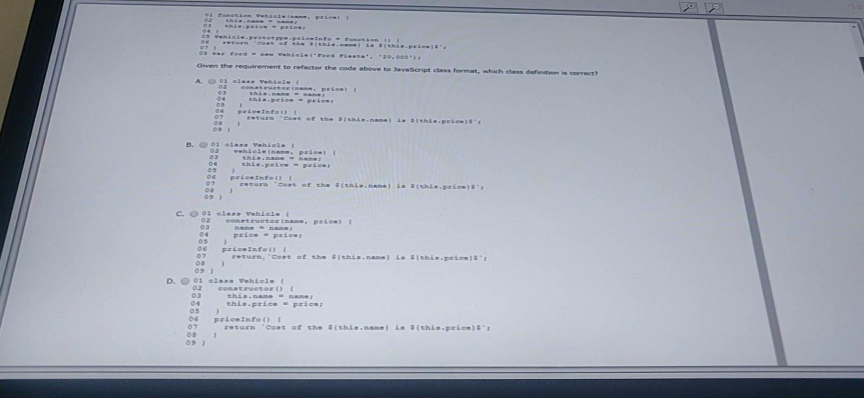

44. **Answer**: A

45

A developer wants to set up a secure web server with Node.js. The developer creates a directory

locally called app-server, and the first file is app-server/index.js

Without using any third-party libraries, what should the developer add to index.js to create the secure web server?

# const https =require(‘https’);

* 1. const server =require(‘secure-server’);
  2. const tls = require(‘tls’);

[www.salesforcekeeda.com](http://www.salesforcekeeda.com/) Telegram: @Salesforcekeeda

* 1. const http =require(‘http’);

**Answer**: A

1. Given the code below:

const delay = sync delay => {

Return new Promise((resolve, reject) => { setTimeout (resolve, delay);});};

const callDelay =async () =>{

const yup =await delay(1000); console.log(1);



What is logged to the console?

A. 1 2 3

B. 1 3 2

C. 2 1 3

# D. 2 3 1

**Answer**: D

1. Refer to the following code: Let obj ={

Foo: 1,

Bar: 2

}

Let output =[],

for(let something in obj{ output.push(something);

}

console.log(output);

What is the output line 11?

A. [1,2]

B. [“bar”,”foo”]

# C. [“foo”,”bar”]

D. [“foo:1”,”bar:2”]

**Answer**: C

1. Refer to the code below?

Let searchString = ‘ look for this ’;

Which two options remove the whitespace from the beginning of searchString? Choose 2 answers

* 1. searchString.trimEnd();

# searchString.trimStart();

[www.salesforcekeeda.com](http://www.salesforcekeeda.com/) Telegram: @Salesforcekeeda

* 1. trimStart(searchString);

# searchString.replace(/*\s\s*/, ‘’);

**Answer**: B,D

1. Which three actions can be using the JavaScript browser console? Choose 3 answers:

# View and change DOM the page.

* 1. DIsplay a report showing the performance of a page.

# Run code that is not related to page.



* 1. **view , change, and debug the JavaScript code of the page.**
  2. View and change security cookies.

# Answer: A,C,D

1. In which situation should a developer include a try .. catch block around their function call ?
   1. The function has an error that should not be silenced.
   2. The function results in an out of memory issue.

# The function might raise a runtime error that needs to be handled.

* 1. The function contains scheduled code.

# Answer: C

1. A class was written to represent items for purchase in an online store, and a second class Representing items that are on sale at a discounted price. THe constructor sets the name to the first value passed in. The pseudocode is below:

Class Item { constructor(name, price) {

… // Constructor Implementation

}

}

Class SaleItem extends Item { constructor (name, price, discount) {

...//Constructor Implementation

}

}

There is a new requirement for a developer to implement a description method that will return a brief description for Item and SaleItem.

Let regItem =new Item(‘Scarf’, 55);

Let saleItem = new SaleItem(‘Shirt’ 80, -1);

[www.salesforcekeeda.com](http://www.salesforcekeeda.com/) Telegram: @Salesforcekeeda

Item.prototype.description = function () { return ‘This is a ’ + this.name;

console.log(regItem.description()); console.log(saleItem.description());

SaleItem.prototype.description = function () { return ‘This is a discounted ’ + this.name; }

console.log(regItem.description()); console.log(saleItem.description());

What is the output when executing the code above ?

* 1. This is a Scarf

Uncaught TypeError: saleItem.description is not a function This is aScarf



This is a discounted Shirt

* 1. This is a Scarf This is a Shirt This is a Scarf

This is a discounted Shirt

* 1. This is a Scarf This is a Shirt

This is a discounted Scarf This is a discounted Shirt

* 1. This is aScarf

Uncaught TypeError: saleItem.description is not a function This is a Shirt

This is a did counted Shirt

# Answer: B

1. GIven the following code: Let x =(‘15’ + 10)*2; What is the value of a?

# A. 3020

B. 1520

1. 50
2. 35

# Answer: A

[www.salesforcekeeda.com](http://www.salesforcekeeda.com/) Telegram: @Salesforcekeeda

1. Refer to the following code: 01 function Tiger(){

02 this.Type = ‘Cat’; 03 this.size = ‘large’; 04 }

05

06 let tony = new Tiger(); 07 tony.roar = () =>{

08 console.log(‘They\’re great1’);

09 };

10



1. function Lion(){
2. this.type = ‘Cat’;
3. this.size = ‘large’;

14 }

15

1. let leo = new Lion();
2. //Insert code here 18 leo.roar();

Which two statements could be inserted at line 17 to enable the function call on line 18? Choose 2 answers.

# Leo.roar = () => { console.log(‘They\’re pretty good:’); };

* 1. Object.assign(leo,Tiger);

# Object.assign(leo,tony);

* 1. Leo.prototype.roar = () => { console.log(‘They\’re pretty good:’); };

**Answer**: A,C

1. Which statement accurately describes an aspect of promises?

# Arguments for the callback function passed to .then() are optional.

* 1. In a.then() function, returning results is not necessary since callbacks will catch the result of a previous promise.
  2. .then() cannot be added after a catch.
  3. .then() manipulates and returns the original promise.

**Answer**: A

[www.salesforcekeeda.com](http://www.salesforcekeeda.com/) Telegram: @Salesforcekeeda

1. Given the code below:

Function myFunction(){ A =5;

Var b =1;

}

myFunction(); console.log(a);

console.log(b); What is the expected output?



* 1. Both lines 08 and 09 are executed, and the variables are outputted.

# Line 08 outputs the variable, but line 09 throws an error.

* 1. Line 08 thrones an error, therefore line 09 is never executed.
  2. Both lines 08 and 09 are executed, but values outputted are undefined.

**Answer**: B

1. Which two console logs outputs NaN ? Choose 2 answers
   1. console.log(10/ Number(‘5’));

# console.log(parseInt(‘two’));

* 1. **console.log(10/ ‘’five);**
  2. console.log(10/0);

**Answer**: B,C

1. Given the following code: Counter = 0;

const logCounter = () => {

console.log(counter);

);

logCounter(); setTimeout(logCOunter, 1100); setInterval(() => {

Counter++ logCounter();

}, 1000);

What is logged by the first four log statements?

A. 0 0 1 2

[www.salesforcekeeda.com](http://www.salesforcekeeda.com/) Telegram: @Salesforcekeeda

B. 0 1 23

C. 0 1 1 2 D. 0 1 2 2

**Answers**: C

1. Refer to the code below:

Function Person(firstName, lastName, eyecolor) { this.firstName

=firstName;



this.lastName = lastName; this.eyeColor

= eyeColor;

}

Person.job = ‘Developer’;

const myFather = new Person(‘John’, ‘Doe’);

console.log(myFather.job);

What is the output after the code executes?

* 1. ReferenceError: eyeColor is not defined
  2. ReferenceError: assignment to undeclared variable “Person”
  3. Developer

# Undefined Answer: D

1. A developer at Universal Containers creates a new landing page based on HTML, CSS, and JavaScript TO ensure that visitors have a good experience, a script named personaliseContext needs to be executed when the webpage is fully loaded (HTML content and all related files ), in order to do some custom initialization.

Which statement should be used to call personalizeWebsiteContent based on the above business requirement?

* 1. document.addEventListener(‘’onDOMContextLoaded’, personalizeWebsiteContext);
  2. window.addEventListener(‘load’,personalizeWebsiteContext);
  3. window.addEventListener(‘onload’, personalizeWebsiteContext);
  4. Document.addEventListener(‘‘’DOMContextLoaded’ , personalizeWebsiteContext);

**Answer**: B

[www.salesforcekeeda.com](http://www.salesforcekeeda.com/) Telegram: @Salesforcekeeda

1. A developer is leading the creation of a new browser application that will serve a single page application. The team wants to use a new web framework Minimalsit.js. The Lead developer wants to advocate for a more seasoned web framework that already has a community around it.

Which two frameworks should the lead developer advocate for? Choose 2 answers

* 1. Vue

# Angular

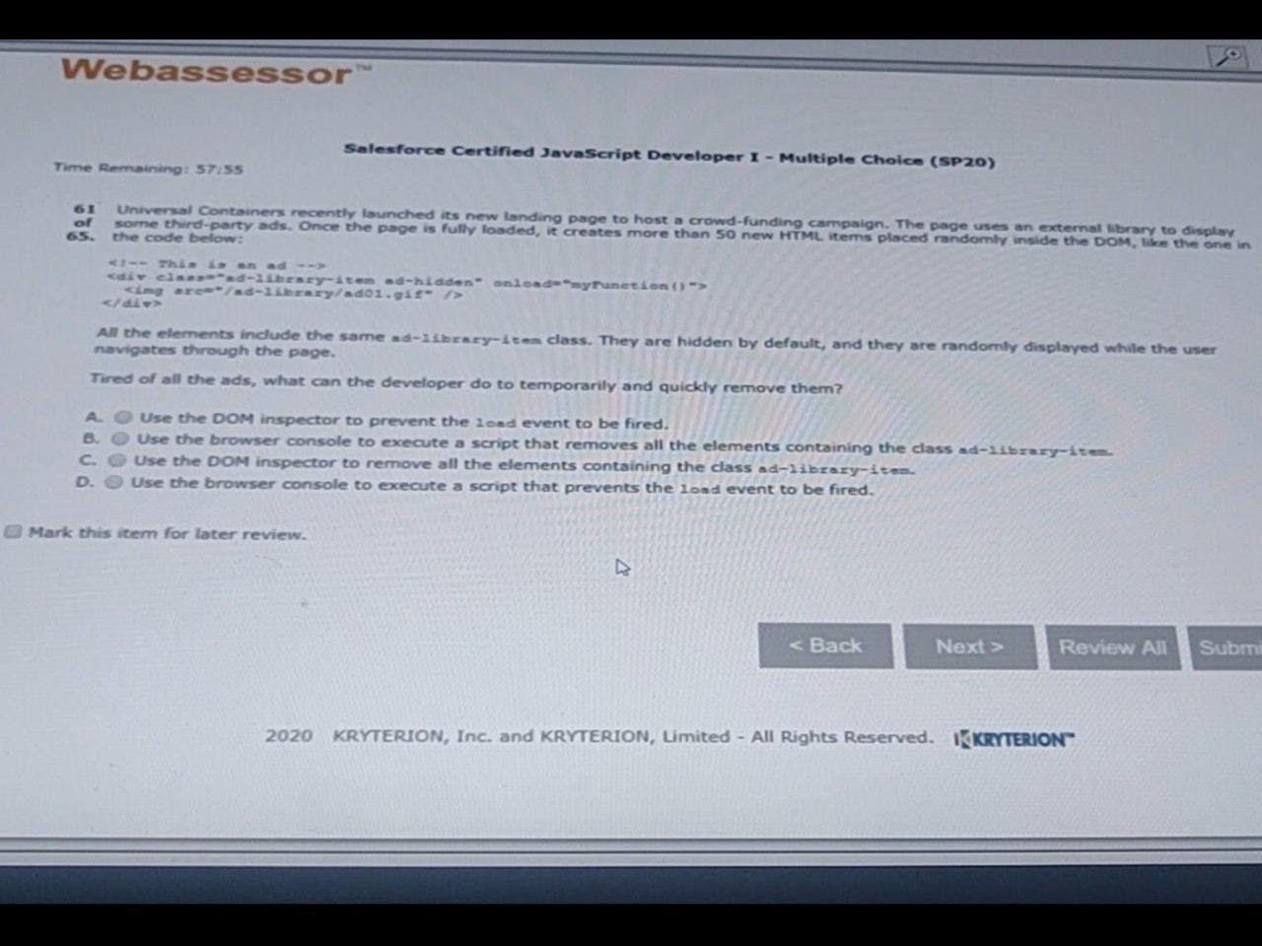

1. Koa
2. **Express Answer**: B,D

61. Universal Containers recently launched its new landing page to host a crowd-funding campaign. The page uses an external library to display some third-party ads. Once the page is fully loaded, it creates more than 50 new HTML items placed randomly inside the DOM, like the one in the code below:

[www.salesforcekeeda.com](http://www.salesforcekeeda.com/) Telegram: @Salesforcekeeda

# B. Use the browser console to execute a script that removes all the elements containing the class ad- library-item.

**Answer**: B

1. Which code statement correctly retrieves and returns an object from localStorage?
   1. const retrieveFromLocalStorage = () =>{

return JSON.stringify(window.localStorage.getItem(storageKey));

}



* 1. const retrieveFromLocalStorage = (storageKey) =>{ return window.localStorage.getItem(storageKey);

}

* 1. const retrieveFromLocalStorage = (storageKey) =>{

return JSON.parse(window.localStorage.getItem(storageKey));

}

* 1. const retrieveFromLocalStorage = (storageKey)=>{ return window.localStorage[storageKey];

}

# Answer:

1. A developer wants to create a simple image upload in the browser using the files API. The HTML is below:

<input type=”file” onchange=”previewFile()”>

<img src=”” height=”200” alt=”Image Preview…”/> The

JavaScript portion is:

1. function previewFile(){
2. const preview = document.querySelector(‘img’);
3. const file =document.querySelector(‘input[type=file]’).files[0]; 04

//line 4 code

1. reader.addEventListener(“load”, () =>{
2. preview.src = reader.result;
3. },false);
4. //line 8 code 09 }

In lines 04 and 08, which code allows the user to select an image from their local computer , and to display the image in the browser?

1. 04 const reader = new File();

08 if (file) URL.createObjectURL(file);

[www.salesforcekeeda.com](http://www.salesforcekeeda.com/) Telegram: @Salesforcekeeda

1. 04 const reader = new FileReader(); 08 if (file) URL.createObjectURL(file);
2. 04 const reader = new File();

08 if (file) reader.readAsDataURL(file);

# D. 04 const reader = new FileReader(); 08 if (file) reader.readAsDataURL(file);



**Answer**: D

1. A developer creates a generic function to log custom messages in the console. To do this, the function below is implemented.
   1. function logStatus(status){
   2. console./*Answer goes here*/{‘Item status is: %s’, status}; 03 } Which three console logging methods allow the use of string substitution in line 02?
2. **Assert**
3. **Log**
4. Message
5. **Info**
6. Error

**Answer: A,B,D**

1. A developer wrote the following code: 01 let X = object.value;

02

* 1. try {
  2. handleObjectValue(X); 05 } catch (error) {

06 handleError(error); 07 }

The developer has a getNextValue function to execute after handleObjectValue(), but does not want to execute getNextValue() if an error occurs.

How can the developer change the code to ensure this behavior?

1. 03 try{
2. handleObjectValue(x);
3. } catch(error){
4. handleError(error); 07 } then {

[www.salesforcekeeda.com](http://www.salesforcekeeda.com/) Telegram: @Salesforcekeeda

08 getNextValue(); 09 }

1. 03 try{
2. handleObjectValue(x);
3. } catch(error){
4. handleError(error); 07 } finally {

08 getNextValue(); 10 }



1. 03 try{
2. handleObjectValue(x);
3. } catch(error){
4. handleError(error); 07 }

08 getNextValue();

# D. 03 try {

**04 handleObjectValue(x)**

**05 ……………………**

**Answer: D**

[www.salesforcekeeda.com](http://www.salesforcekeeda.com/) Telegram: @Salesforcekeeda